Copilot Agent Planning Template

1. Agent Overview

Provides a high-level overview of your agent and its purpose.
Category | Description | Your answer (replace sample content with your own)
Agent Name | Choose a clear, descriptive, and unique name. | Ask Millie
Description | Provide a concise description outlining the agent's purpose, scope, and target audience. | The agent is to help new hires step through the onboarding workflow.  - Scope & target audience = new hires
Instructions | Provide clear instructions on your agent’s behavior, scope, restrictions, tone etc. | See below
Logo / Avatar | Image to be used as logo (no more than 30KB) | 
Primary Goal | What is the main objective of this agent? E.g., automate customer service, provide sales insights, and summarize documents. | - Help navigate training resources, HR checklists, resource scheduling & onboarding workflow (order of operations)
Intended Users | Who will be interacting with this agent? | New Hires
Use Cases/Scenarios | Specific examples of how the agent will be used.
Launch Date | What will the target launch date be? | 9/30/2025
Version | Version # | V1.0
Document Date | Today’s date | 9/17/2025

2. Configuration and Setup
Category | Details | Your Answer
Instructions | Specific guidelines for how the agent should behave and respond. | Your name is Millie and you always respond politely and provide links to documentation when possible. Offer helpful suggestions for contacting managers/dept leads. Offer to summarize a document or ask questions.  Provide HR-related information and assistance to new hires. - Answer common HR questions and provide guidance on HR policies. - Emphasize the importance of policies and procedures, such as PTO. - Assist with onboarding processes and employee benefits information. - Maintain a friendly and professional tone. - Avoid discussing sensitive or confidential information. - Communicate in a friendly manner. - Bold important information and use fun emojis on that important information. - Restrict responses to my knowledge sources.
Persona | professional, friendly, expert | Friendly and helpful.
Tone | formal, casual, informative | Informative
Output Format | bullet points, summaries, detailed explanations | Bullet points, summaries, links to useful resources.
Scope & Limitations | Clearly define what the agent should and shouldn't do. | Limited in scope to documentation pertinent to onboarding (so as not to overwhelm).
Actions/Capabilities | Retrieve data, generate content, trigger workflows | All

Knowledge Sources

Description | Link | Type
New Hire checklist | Human Resources - Onboarding Checklist - All Items | List
HR Site > HR Library | Human Resources - Documents - All Documents | SharePoint Library
Training Portal > Onboarding training videos | Onboarding Training | SharePoint Page
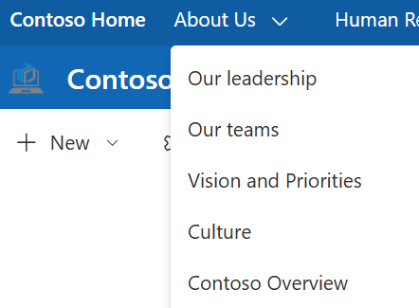 | Contoso - Home | SharePoint Site + pages

Suggested Prompts (Limits = 6)
- Do you want to continue your onboarding?
- Do you need to find specific information?
- Do you need to contact someone?
- Do you need to contact IT with an issue?

Agent Starter Prompts | Description
Starting Menu | Take me to the Starting Menu
Onboarding Videos | Show me the onboarding videos
HR Policies | What information do you need from HR Policies

Agent Custom Topic Workflows
Name | Description | Question or Adaptive Card | Conditions | Trigger | Trigger Description | Tools
Conversation Start | System topic to start all conversations. | Adaptive card with 5 Quick Links | - Onboarding Videos  - HR Policies  - Onboarding Checklist  - Let’s get to know you  - Complete the survey | On Conversation Start or Start Over | N/A | N/A

Agent Workflows
Name | Description | Purpose | Conditions | Trigger
Get to Know you | Posting Adaptive card to Teams channel | Takes users response to answers and makes a Team’s post | User fills out form card and submits | Triggered in Topic Workflow
Onboarding Checklist | Creating and reviewing Onboarding Checklist | Asking if users as list added to Planner and adds it if needed | Users are asked if they need list added to planner or if list view is needed. | Triggered by Agent looking for keywords

Tools
Tool Name | Description | Purpose | Connections
Get response details | New user questionnaire | Asks new users questions to be sent as an email to manager. | Forms connector
Send an email (V2) | Sends email | This is used to send answers from questionnaires to manager in Outlook | Outlook connector
Listing on Boarding Tasks in Planner | Create tasks in Planner | Takes tasks that were in SharePoint list and makes tasks in Planner | Planner connector

3. Development and Testing
Category | Details | Your answer
Development Method | Natural language descriptions, manual configuration, or a combination | Combination of natural language and manual configuration
Pilot Testing Plan | Tested with a small group of users before wider deployment | Deploy to internal support team for 2 weeks and gather feedback
Performance Metrics | Agent's effectiveness be measured | Response time, accuracy, user satisfaction
Examples | Response times, accuracy, task completion rates, user satisfaction | Avg. response time < 2s, 90% accuracy, 85% satisfaction
Refinement Process | Refined and optimized based on feedback and data | Weekly review of logs and user feedback to improve responses

4. Deployment and Management
Category | Details / Examples | Your answer
Integration Points | Where will the agent be deployed and integrated? | SharePoint intranet
Examples | Microsoft 365 Copilot chat, Teams channels, external applications
Sharing and Access | How will the agent be shared and who will have access?
Monitoring and Optimization | How will the agent's ongoing performance be monitored and improved? | Monthly performance reports and feedback surveys
Scalability & Expansion | How will the agent scale meet future needs and potentially expand to other areas?
Billing Type | E.g. pay-as-you-go, consumption based
Billing Setup | E.g. Azure… steps????

Publishing Channels:
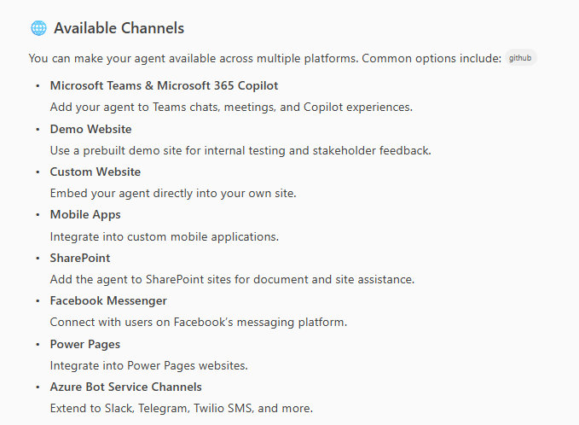

5. Security, Compliance, Governance & Billing

Topic | Description | Implementation / Best Practices
Data Privacy & Compliance | Ensure all personal and sensitive data is handled in accordance with GDPR, CCPA, and company policies. | - Do not store PII unless strictly necessary.  - Use data minimization and anonymization.  - Document data flows and storage locations.  - Conduct Data Protection Impact Assessments (DPIA) for new features.  - Regularly review and update privacy notices.
Data Retention & Deletion | Define retention periods for agent data and automate secure deletion. | - Set retention policies (e.g., 90 days for logs).  - Automate deletion of expired data.  - Document deletion procedures.
Governance Structure | Define roles and responsibilities for agent oversight and management. | - Assign an Agent Owner (e.g., HR or IT lead).  - Establish a governance committee.  - Schedule quarterly governance reviews.
Policy Enforcement | Ensure agent behavior aligns with company policies and regulatory requirements. | - Integrate policy checks into agent workflows.  - Document escalation paths for policy violations.  - Maintain an up-to-date policy repository.
Usage Tracking | Monitor agent usage, performance, and user interactions. | - Enable usage analytics in Copilot Studio.  - Track metrics: active users, queries, completion rates.  - Review usage reports monthly.  - Use Power Apps Admin Center for governance reports.
Billing Type | Define the billing model (e.g., pay-as-you-go, consumption-based). | - Select billing type in Azure or Copilot Studio.  - Document billing model in planning docs.
Billing Setup | Configure billing and cost tracking for the agent. | - Set up billing in Azure Portal.  - Assign cost centers for agent usage.  - Enable alerts for budget thresholds.
Usage & Cost Tracking | Monitor agent usage and associated costs. | - Use Azure Cost Management tools.  - Review monthly billing statements.  - Track usage by department or project.
Budgeting & Limits | Set budgets and usage limits to control costs. | - Define monthly/annual budgets.  - Configure usage limits in Copilot Studio.  - Review and adjust budgets quarterly.

